**Chapter 6**

**Applications of Integration**

**6.3 Volumes of Revolution: Cylindrical Shells**

**Section Exercises**

**For the following exercise, find the volume generated when the region between the two curves is rotated around the given axis. Use both the shell method and the washer method. Use technology to graph the functions and draw a typical slice by hand.**

115. **[T]** Under the curve of rotated around the 

Answer:

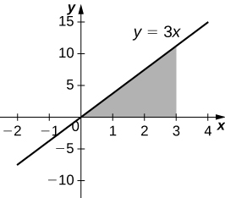

 units3

117. **[T]** Under the curve of  rotated around the 

Answer:

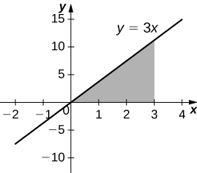

 units3

119. **[T]** Under the curve of  rotated around the

Answer:

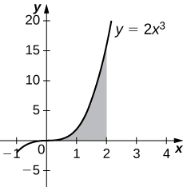

 units3

**For the following exercises, use shells to find the volumes of the given solids. Note that the rotated regions lie between the curve and the *x*-axis and are rotated around the *y*-axis.**

121. 

Answer: units3

123. 

Answer: units3

125. 

Answer: units3

127. 

Answer: units3

129. 

Answer: units3

**For the following exercises, use shells to find the volume generated by rotating the regions between the given curve and  around the *x*-axis.**

131. 

Answer: units3

133. 

Answer: units3

135. 

Answer: units3

137. 

Answer: units3

139. 

Answer: units3

**For the following exercises, find the volume generated when the region between the curves is rotated around the given axis.**

141.  rotated around the

Answer: units3

143.  rotated around the line

Answer: units3

145.  rotated around the

Answer: units3

147.  rotated around the

Answer: units3

149. **[T]** Left of  right of around the 

Answer:  units3

**For the following exercises, use technology to graph the region. Determine which method you think would be easiest to use to calculate the volume generated when the function is rotated around the specified axis. Then, use your chosen method to find the volume.**

151. **[T]**  rotated around the

Answer:

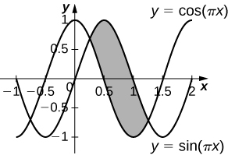

 units3

153. **[T]** rotated around the

Answer:

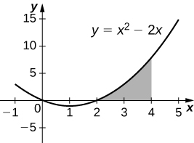

 units3

155. **[T]**  rotated around the

Answer:

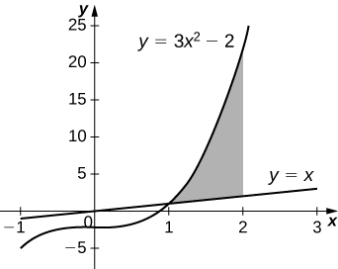

 units3

157. **[T]** rotated around the

Answer:

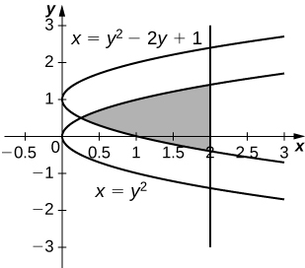

 units3

**For the following exercises, use the method of shells to approximate the volumes of some common objects, which are pictured in accompanying figures.**

159. Use the method of shells to find the volume of a cone with radius and height

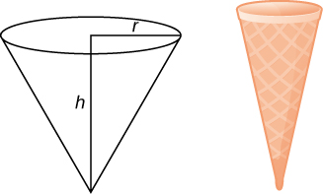

Answer:  units3

161. Use the method of shells to find the volume of a cylinder with radius  and height .

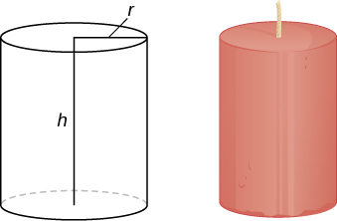

Answer: units3

163. Consider the region enclosed by the graphs of and . What is the volume of the solid generated when this region is rotated around the Assume that the function is defined over the interval .

Answer: units3

This file is copyright 2016, Rice University. All Rights Reserved.